REPORT OF THE EDUCATIONAL TOUR
DEPT. OF MUSIC
DATED: 10.01.2025

A one-day study tour was organized by the Department of Music, Netaji Satabarshiki Mahavidyalaya on 10th January 2025, at Banipur Lok Utsav, Asia’s second-largest Rural Folk Fair. The group comprised 23 students from Semesters I, III, and V, accompanied by the faculty members of the department.
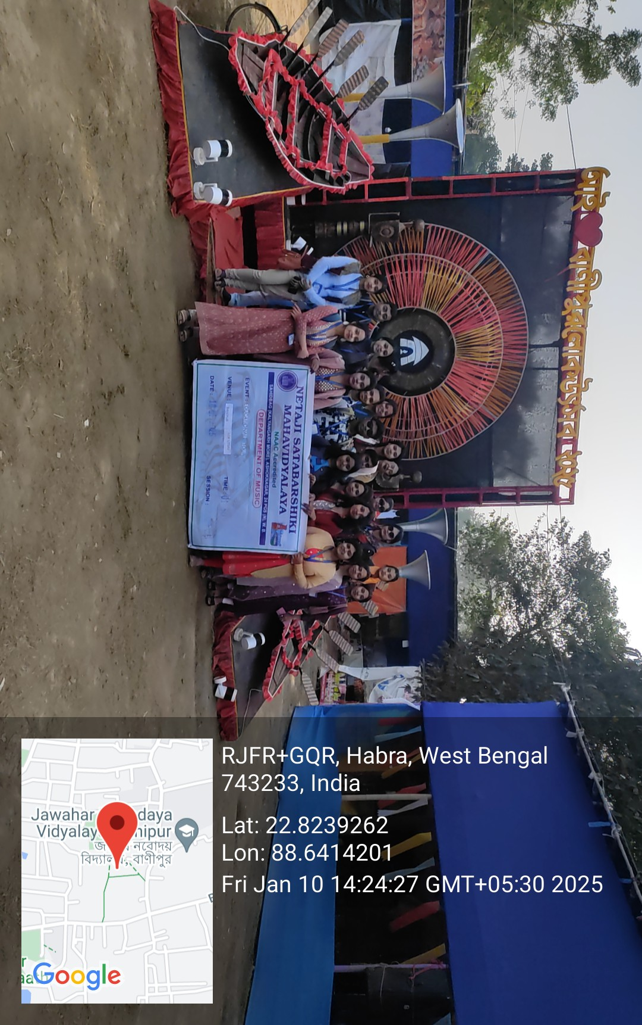
We gathered at the college premises around 1:30 p.m. to head towards Banipur Lok Utsav, and within half an hour, we reached our destination.
The visit provided great exposure for our students, offering them a glimpse into the socio-folk culture of our society. They gained firsthand experience with various traditional musical instruments that are not very popular among today’s youth but still hold immense significance — such as the Ektara (a string instrument), Bansi (a blowing instrument), and Ananda Lahari. The students also had candid interactions with the artisans and musicians behind these instruments, learning about their skills, dedications and traditions.
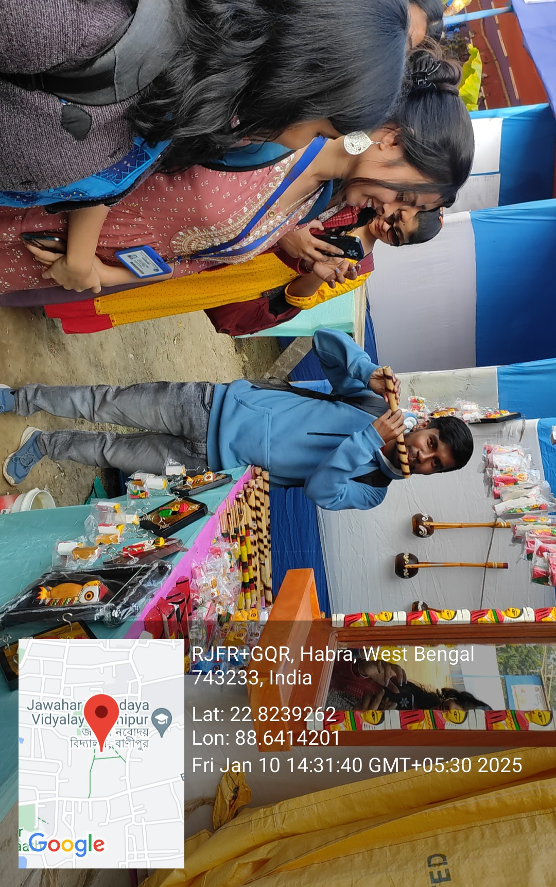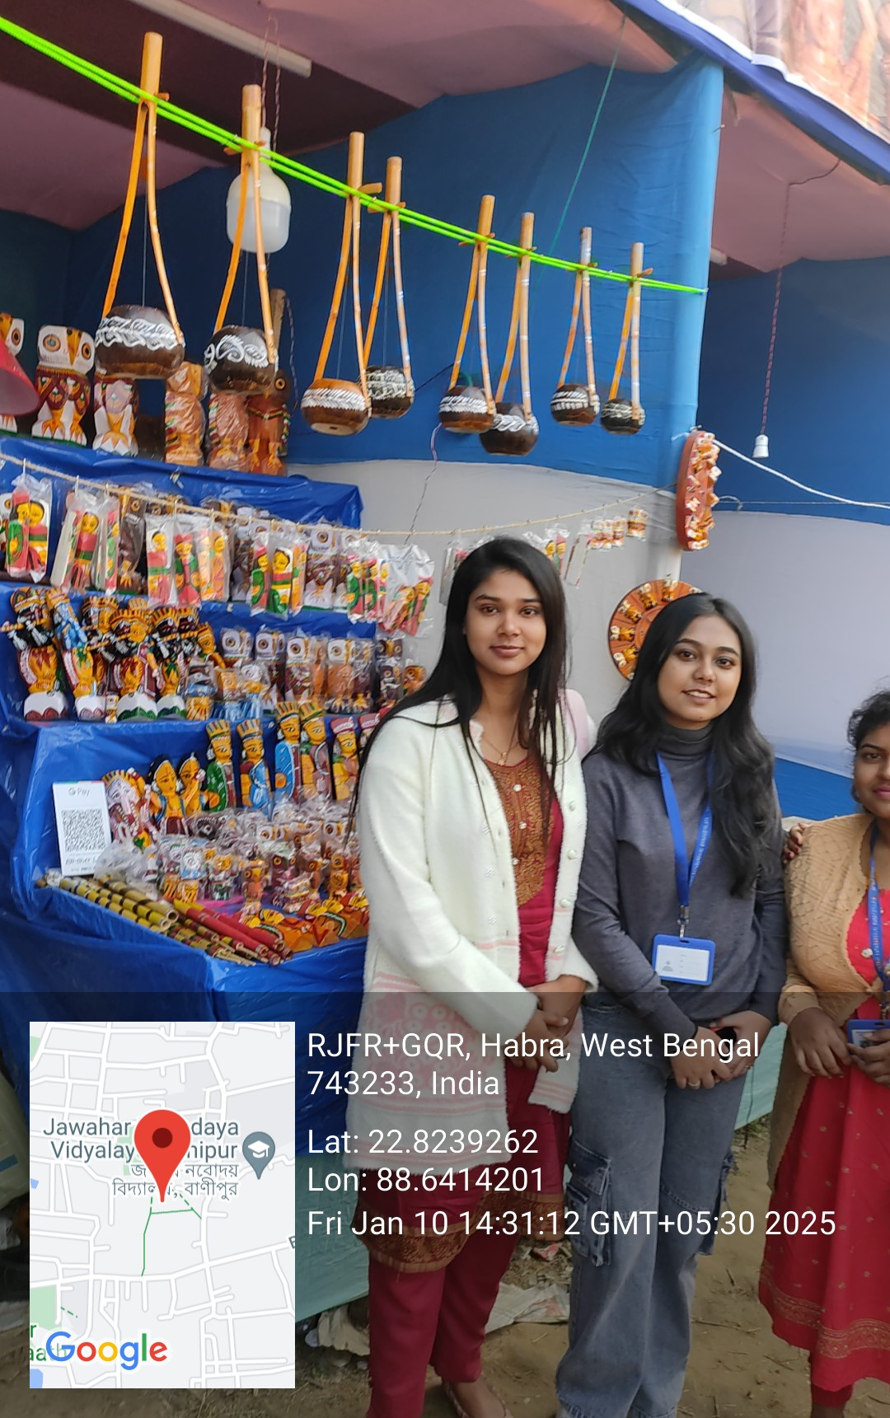

A special stage was dedicated to Ustad Rashid Khan, a true institution for learners of Indian classical music. The stage highlighted his lifelong contribution to Indian Classical Music and inspired our students deeply. The girls from our group then eagerly moved towards “SABALA MANCHA,” an inspirational platform at Banipur Mela dedicated to empowering young women by providing them an opportunity to showcase their talents and receive small rewards in return.
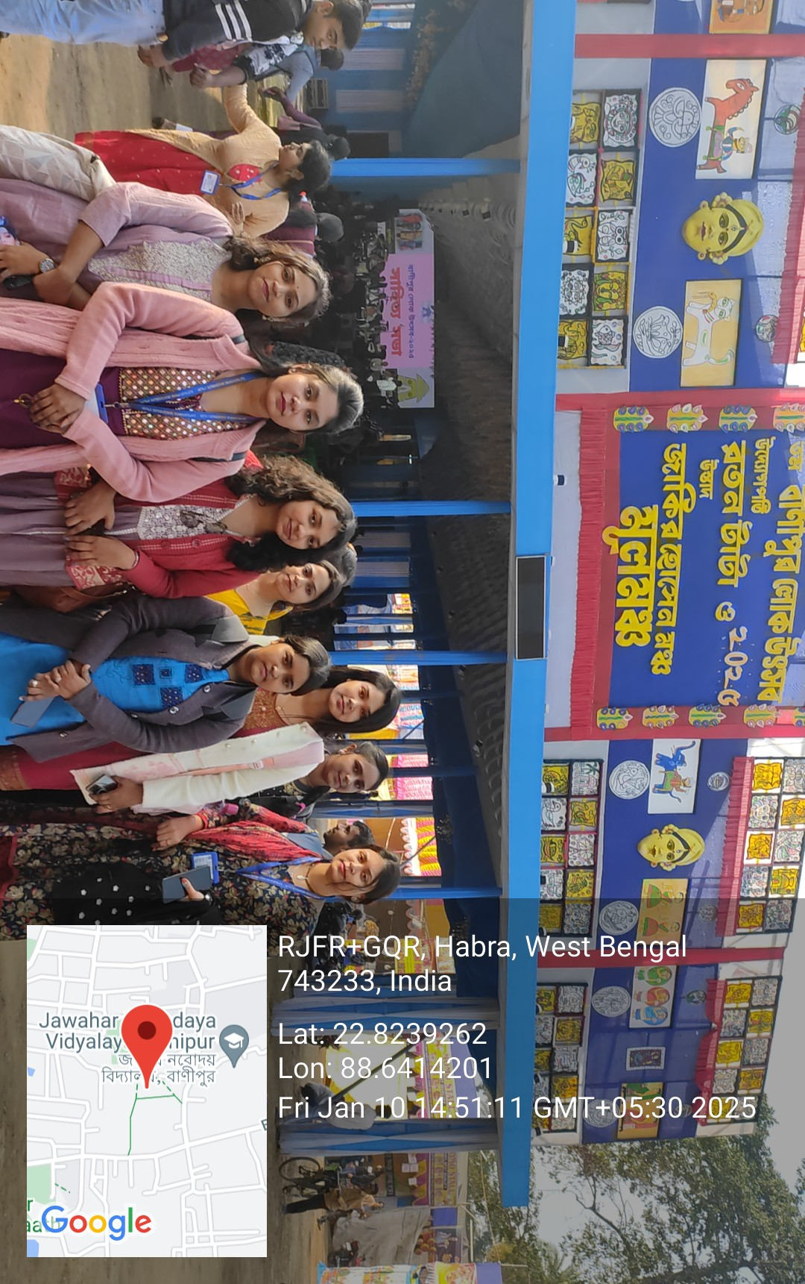
Next, we visited the Art & Craft Gallery, where several students showed great interest in various stalls displaying handmade jewelry and decorative items. Through this experience, they gained valuable insights into self-reliance and how the creation and sale of such artifacts can promote self-employment and entrepreneurship.
Finally, the irresistible aroma from the Food Court drew us in, and we delighted to savour our taste buds with delicious snacks and sweets. The day ended on a sweet and musical note with a mesmerizing performance by an artist on the central stage. Gradually, we left the Mela, our minds still resonating with the rhythm and charm of her soulful performance.
The tour proved to be an enriching and memorable experience — a journey through the vibrant world of rural folk culture, art, and music that truly broadened our students’ horizons.

