Report of the Educational Tour
Department of Music

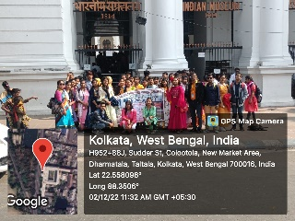
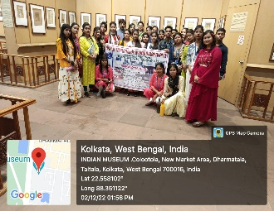
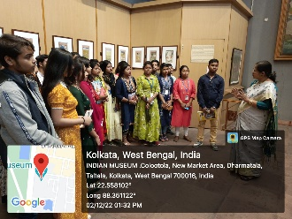
Department of Music arranged their Education Tour for the session 2022-23 on 02.12.2022 at The Indian Museum Kolkata. 5 Teachers and 25 Students from all Semesters (Semester-I, III and V) participated the tour with great enthusiasm and pleasure. ‘History of Indian Music’ is a Core Paper (MUCACOR03T) of the syllabi of Music Hounours, which includes evolutions of music in Ancient, Medieval and Modern Period. So, the department decided to visit the museum for making the subject easy to the students with a wholesome knowledge of Indian Music. The models, photos and scriptures helped the students to understand the evolution of Music from the Primitive Age to Modern Age. They experienced the textbook contents in real form. The students could understand how the music was formed and developed in ancient society. The students enjoyed and gained knowledge by the displayed models of different dance forms, musical instruments, of which they usually learn in their books. In the Photo Gallery they experienced the ‘Raga Dhyana Chitras’ that are mentioned in their books. Thus, they could understand easily that every Raga has their own Theme and Image. The students also could understand the basic differences of North Indian and South Indian dance forms and musical instruments while observing the models. They also observed and experienced the Folk Instruments used in different regions of India. They eagerly enjoyed the gallery of Western Musical Instruments. They also experienced the evolution of media from Radio to TV, Gramophone to CD and consequently today’s social media.
The tour ended successfully with experiential learning and enjoyment of the students beyond classroom teaching with the teachers.

Papri Chakrabarti
HOD of Music

